1.Title / Content Area: | The Amish and Mennonites: A Case Study in Folk Cultures | 
2. Developed by: | Bob Harpur
3. Grade Level: | High School
4. Geographic Thinking Skill(s): | Analyze how historical events and the spatial diffusion of ideas, technologies, and cultural practices have influenced migration patterns and the distribution of the human population.
5. Essential Question: | What are the characteristics of a Folk Culture and how do they continue to live in modern America?
6. Contextual Paragraph (Connect to Geographic Thinking) | The Pennsylvania Germans  The first Germans to settle in Pennsylvania came in 1683 from Krefeld, Germany.  Small sects (like the Mennonites and Amish) that shared Quaker principles emigrated to America to escape religious persecution. William Penn and his agents encouraged German and European emigration to Pennsylvania by circulating promotional literature touting the economic advantages of Pennsylvania as well as the religious liberty available there.  Beginning in the 1720s significantly larger numbers of German Lutherans and German Reformed arrived in Pennsylvania. Many were motivated by economic considerations.  From: Religion and the Founding of the American Republic  America as a Religious Refuge: The Seventeenth Century, Part 2 - Library of Congress  Today the Amish and Mennonites are found across the United States and Canada in many concentrated areas of agricultural and urban communities.  How are they doing and what can we learn about them to help us understand the establishment and continuation of their cultures?

Annotated Resource Set (ARS)
Phase I
6. Resource Set
The Two Worlds of the Pennsylvania Dutch, illustrated lecture presented by Don Yoder, professor emeritus, University of Pennsylvania. | Mennonite / Amish Genealogy | A Mennonites protest against military service, 1775. | Baptismal Certificate | The Narrow Gate | German emigrants for New York embarking on a Hamburg steamer.  Courtesy of the Library of Congress Prints and Photographs Division  Washington, D.C. 20540 USA.
The "two worlds" are those of the "Plain Dutch" — Amish, Mennonites, and Brethren — and the much larger world of the Lutheran and Recorded churches of the German and Swiss Reformates. | In 1525 several sects of Anabaptists split from the Roman Catholic Church during the Protestant Reformation. Mennonites were formed in 1537 (USA 1725) and the Amish in 1693. | Society of Mennonites  Philadelphia, 1775.  Created and published | This certificate features characteristic Pennsylvania German motifs.  Pennsylvania German fraktur woodcut with watercolor, 1807.  Prints & Photographs Division, Library of Congress (31) | This Pennsylvania German illustration depicts a familiar 19th century evangelical motif of the narrow gate to Heaven and the broad and seductive road to Hell, where the devil and his minions await the self-satisfied sinner. | Germans by the millions traveled to the United states because of religious persecution and economic despair.
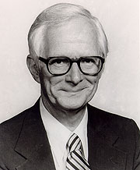 | 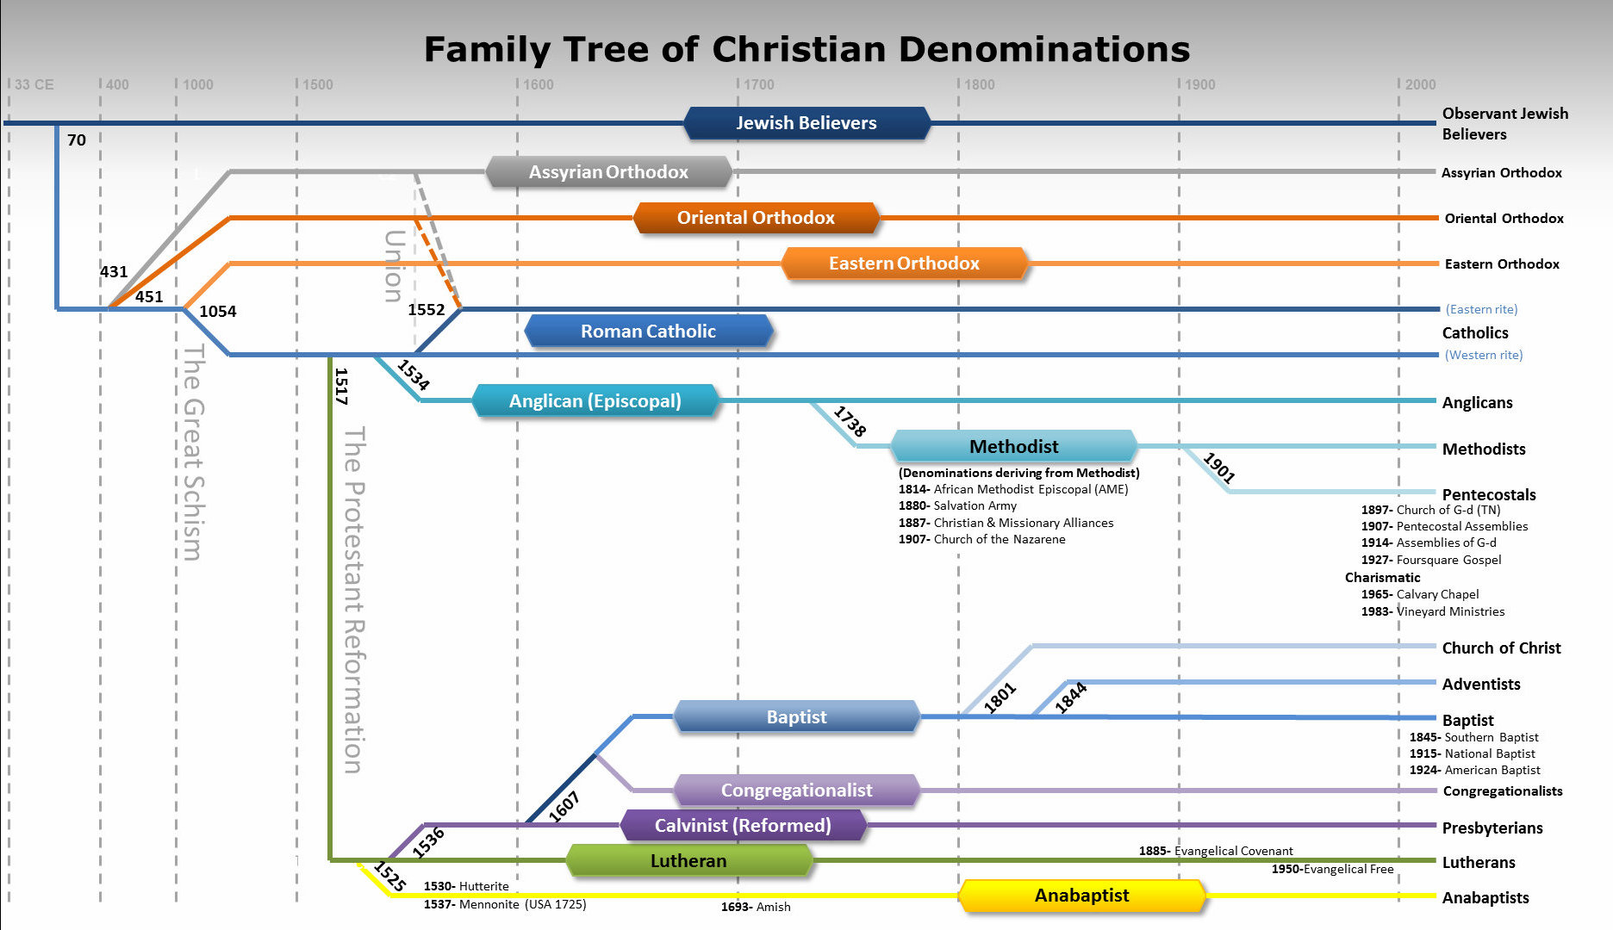 | 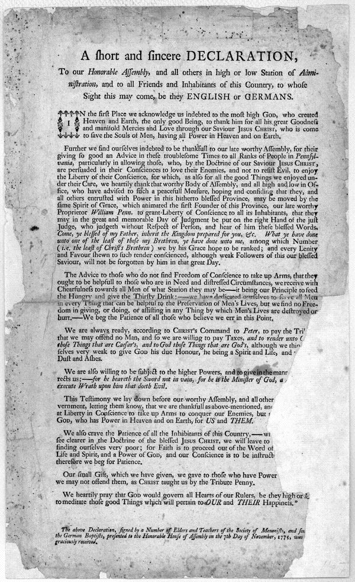 | 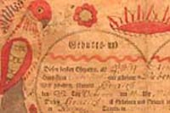 | 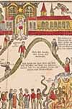 | 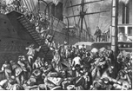
http://www.loc.gov/folklife/events/BotkinArchives/2011flyers/YoderFlyer.html | http://www.psalm11918.org/References/Technical-References/Family-Tree-of-Christian-Denominations.html | http://memory.loc.gov/cgi-bin/ampage?collId=rbpe&fileName=rbpe14/rbpe144/14401300/rbpe14401300.db&recNum=0&itemLink=h?ammem/rbpebib:@field(NUMBER+@band(rbpe+14401300))&linkText=0 | http://www.loc.gov/pictures/item/98508303/ | http://www.loc.gov/exhibits/religion/rel01-2.html | http://www.neh.gov/files/imagecache/neh_large/divisions/preservation/images/germanimmigrants-resize.jpg

Lancaster County, Pennsylvania. Amish and Mennonite women at farm auction | Ephrata, Pennsylvania (vicinity). Butchering pork on a Mennonite farm | Map of Lancaster County, Pennsylvania. | Amish wagon shop | Worker in an Amish wagon shop | Harness repair man and shoemaker
Photographed in March 1942 in Lancaster Pa. during WWII | 1942 March | One of the first areas in the country settled by the Anabaptists – Amish and Mennonites | A buggy is the primary mode of transportation in Amish areas. | Hand tools being used to shape the buggy | Horse harnesses and accessories are finely crafted in the Amish tradition
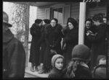 | 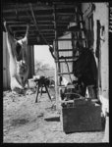 | 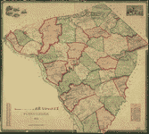 | 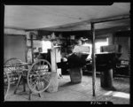 |  | 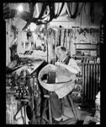
http://hdl.loc.gov/loc.pnp/fsa.8c26418 | http://hdl.loc.gov/loc.pnp/fsa.8c26474 | http://hdl.loc.gov/loc.gmd/g3823l.la000762  https://en.wikipedia.org/wiki/Lancaster_County,_Pennsylvania | http://hdl.loc.gov/loc.pnp/fsa.8c26516 | http://hdl.loc.gov/loc.pnp/fsa.8c26502 | http://hdl.loc.gov/loc.pnp/fsa.8c26519

Amish horse, buggy, and family at a small home in Lancaster County, Pennsylvania | Amish walking to church service  Secondary Source | Amish: A Secret Life  Secondary Source | Number of Amish Church Districts  Secondary Source | Number of Amish Adherents by State, 2010  Secondary Source | Lancaster Pennsylvania  Web Site  Secondary Source
Contributor Names  Highsmith, Carol M., 1946-, photographer  Created / Published  [between 1980 and 2006] | What is Amish?  Living life to avoid the distractions and temptations of the outside world. | David and Miriam Lapp risk excommunication for allowing themselves to be filmed for this video by BBC,  They are old order Amish who are young and look to a higher power for their lives. | Map depicts the number of local church districts in various states. | This map is included here in order to visualize the spread of the Amish religion in the United States. | Modern Amish and Mennonite communities and their lifestyles.
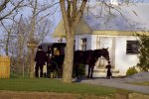 | 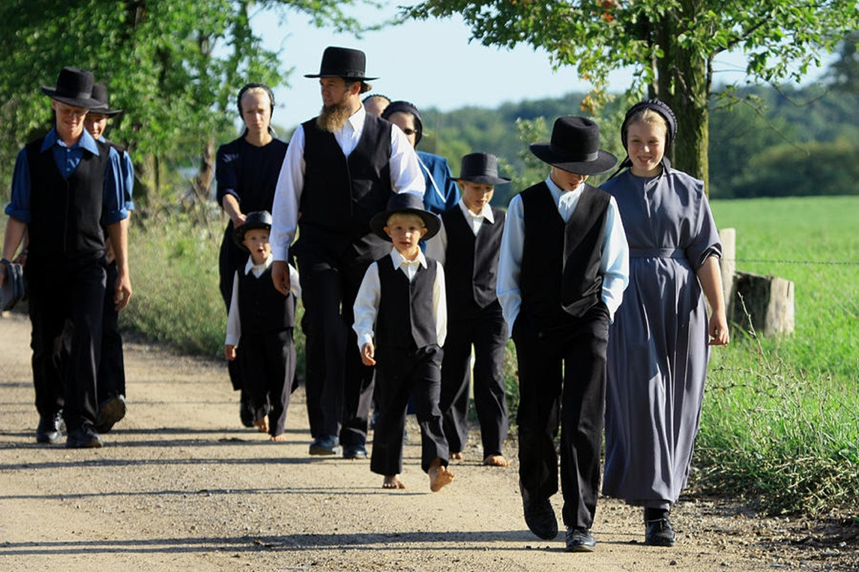 | 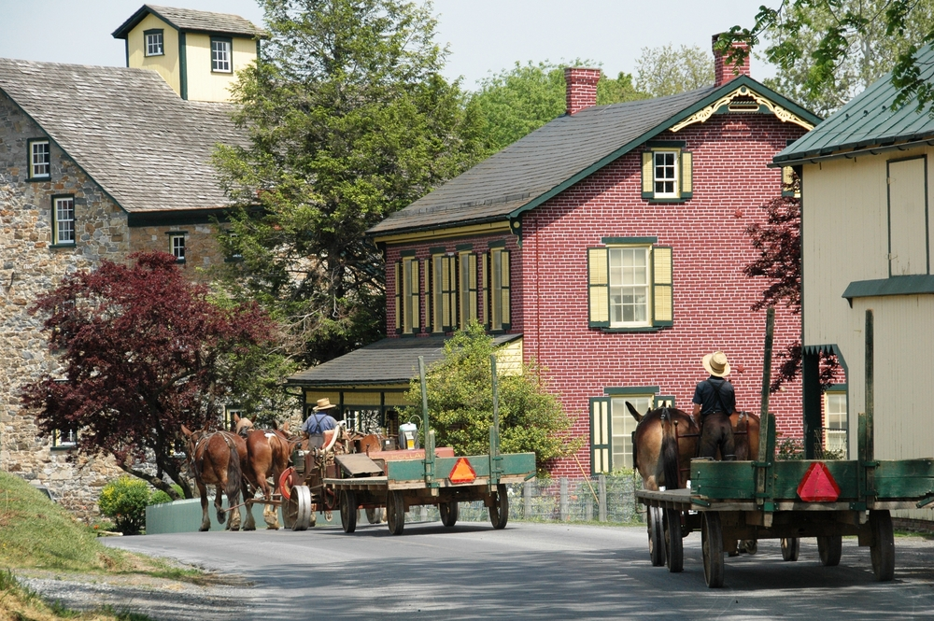 | 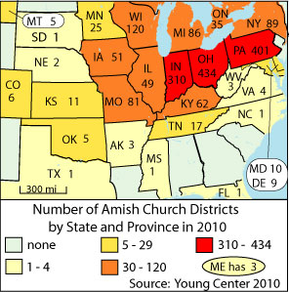 | 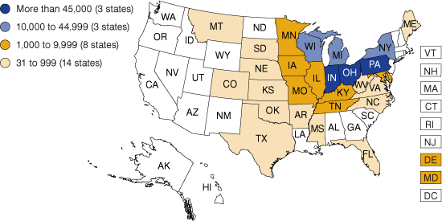 | An Amish farmer raking hay in his field  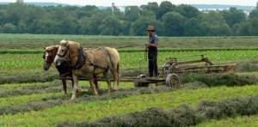
http://www.loc.gov/item/2011632696/ | https://en.wikipedia.org/wiki/Amish  http://www.enkivillage.com/amish-rules.html | https://www.youtube.com/watch?v=HtNXvE_rLoE | Young Center 2010 | http://www.incontext.indiana.edu/2012/nov-dec/article2.asp | http://lancasterpa.com/amish/

Phase II
Foundations Annotations
7. Curriculum Connections

Connections to History, Geography, Language Arts, Information and Communication Technology
8. Curriculum Standards

9-10 Reading Standards for Literacy in History/Social Studies

Key Ideas and Details
9-10.RH.1 Cite specific textual evidence to support analysis of primary and secondary sources, attending to such features as the date and origin of the information.
9-10.RH.2 Determine the central ideas or information of a primary or secondary source; provide an accurate summary of how key events or ideas develop over the course of the text.

Craft and Structure
9-10.RH.4 Determine the meaning of words and phrases as they are used in a text, including vocabulary specific to domains related to history/social studies.

Integration of Knowledge and Ideas
9-10.RH.9 Compare and contrast treatments of the same topic in several primary and secondary sources.

9-10 Writing Standards for Literacy in History/Social Studies

Key Ideas and Details
9-10.WHST.4 Produce clear and coherent writing in which the development, organization, and style are appropriate to task, purpose, and audience.
9-10.WHST.8 Gather relevant information from multiple authoritative print and digital sources, using advanced searches effectively; assess the usefulness of each source in answering the research question; integrate information into the text selectively to maintain the flow of ideas, avoiding plagiarism and following a standard format for citation.
9-10.WHST.9 Draw evidence from informational texts to support analysis reflection, and research.
AZ. Social Studies Standards
American History Strand 1
Concept 3: Exploration and Colonization
PO 2. Describe the reasons for colonization of America (e.g., religious freedom, desire for land, economic opportunity, and a new life).
PO 3. Compare the characteristics of the New England, Middle, and Southern colonies:
- Colonial governments - geographic influences, resources and economic systems
- religious beliefs and social patterns
National Geography Standards

Essential Element: The World in Spatial Terms
1. How to use maps and other geographic representations, geospatial technologies, and spatial thinking to understand and communicate information
Essential Element: Human Systems
9. The characteristics, distribution and migration of human populations on Earth’s surface
12. The processes, patterns, and functions of human settlement

Essential Element: The Uses of Geography
17. How to apply geography to interpret the past
9. Content & Thinking Objectives

Content Objectives:
Objective 1: Understand the differences between primary and secondary sources.
Objective 2: Identify primary source collections related to student-generated questions.
Objective 3: Search for, select, question, and analyze primary sources for relevance to a particular historical inquiry.

Thinking Objectives:
Objective 1: Recognize and define stages of inquiry.
Objective 2: Develop strong questions with potential to identify a focus and guide further inquiry.
Objective 3: Decide which primary sources to accept or reject based on relevance to topic and questions.
10. Inquiry Activities & Strategies

What are the characteristics of a Folk Culture and how do they manage to flourish in modern America?
Introduce the lesson by asking learners to think about the characteristics of a Folk Culture – have them brainstorm as a class.
Explain to the students that they will be developing their own knowledge of the Folk Cultures based on primary and secondary sources.
Show students the Inquiry Process Model developed by Barbara K. Stripling. Explain to them what it is and how to use it.
They will be following an inquiry process to build this knowledge. It will be important to ask questions throughout the process and to seek answers to those questions. Learners will use various Analysis Tools with a Geographic Lens as provided by the instructor to focus and record the answers.
Think, pair, share – Use the Analysis Tools with a Geographic Lens and have the learners work together to learn about each ARS resource they investigated.

11. Assessment Strategies

- Use a group reporting-out session to express to the class their new knowledge.
- Have all learners write a short essay using information from their analysis tools and class discussion expressing their understanding of the characteristics of a Folk Culture and how they manage to flourish in America.
- All learners will write a short reflection on their use of the Inquiry Process to learn about Folk Cultures as represented by the Amish and Mennonite.

AASL Standards for the 21st Century Learner
Self-Assessment Strategies:

1.4.1 Monitor own information-seeking processes for effectiveness and progress, and adapt as necessary.

2.4.1 Determine how to act on information (accept, reject, modify).

Other Resources
12. Web Resources

Religious Pluralism in the Middle Colonies
http://nationalhumanitiescenter.org/tserve/eighteen/ekeyinfo/elinksmidcol.htm

13. Secondary Sources

Amish Today
http://www.pbs.org/wgbh/americanexperience/features/introduction/amish-introduction/

http://lancasterpa.com/amish/

https://en.wikipedia.org/wiki/Amish

Mennonite Today

https://en.wikipedia.org/wiki/Mennonite

Anabaptists History

http://www.anabaptists.org/history/german-migration-to-north-america.html

14. Print and Other Media Resources



