GeoInquiry Application
2 Day Alliance Summer Geography Institute
Focus on Geo-Inquiry
Friday and Saturday, June 22-23, 2018

In this institute, educators will learn how to:
- Develop Geographic Questions
- Acquire Geographic Information
- Organize and Analyze Geographic Information
- Develop Geographic Stories
- Share Geographic Stories

Eligibility:
Only 20 teachers (teams of 2) will be selected to participate in this professional development opportunity. Preference will be shown to teams of 2--consisting of one middle school science or social studies teacher paired with a media or technology specialist from the same middle school. Participants must be employed full-time as teachers in a classroom.

Location:
Rhodes Junior High School
1860 S. Longmore St.
Mesa, AZ 85202

Participants who complete all requirements will receive:
- A stipend of $200
- Room costs for residential participants (To qualify, you must live 30 miles or more from Rhodes Jr. High.)
- Snacks and lunch
- A stipend of $25 for travel

Requirements that need to be completed to receive the stipend:
- Participants must attend all sessions (9:00 AM to 4:00 PM) each day.
- Teams must complete at least one GeoInquiry project with at least 25 students by November 30, 2018.
- Participants must work cooperatively with school partners as well as others in the institute.

What is an Geo-Inquiry project?

The Geo-Inquiry Process is a five-step method designed to teach the skills necessary to think and reason geographically, and includes asking Geo-Inquiry Questions, acquiring
geographic information, organizing and analyzing information,and using the information to answer Geo-Inquiry Questions for informed action. The Geo-Inquiry Process relies on geographic perspective as a foundation, offering students a unique lens to analyze space, place, and the interconnections of systems in our world. Geographic perspective is interdisciplinary and allows for the examination of complex issues at various scales. Think of scale as being the “zoom lens” of geography. The scale can be local, regional, or global. By using a geographic perspective with the Geo-Inquiry Process, students begin to connect complex components, see patterns, and make connections as they look at the world differently in order to make informed predictions, well-reasoned decisions, and take action

Step 1: The Geo-Inquiry Process is designed to build on student questions that reflect their interests and issues in their local community. This process is project-based, authentic, and
experiential in nature. It requires students spend time asking, investigating, organizing, analyzing, and creating. This process is best done in groups rather than individually.

Step 2: Once students have selected the Geo-Inquiry Question, they will need to determine the following:
• What data will they need to collect?
• How will they collect the data?
• How long will it take to collect the data?
• What type of research will they need to do?
• Who should they talk to about the issue?

Step 3: Students now organize the data they have collected, visualizing that data in a way that conveys an understanding of the issue they are researching, and putting that data onto a map or displaying it with visuals. The Geo-Inquiry Process focuses on using the geographic lens as a way to better share data and tell a story.

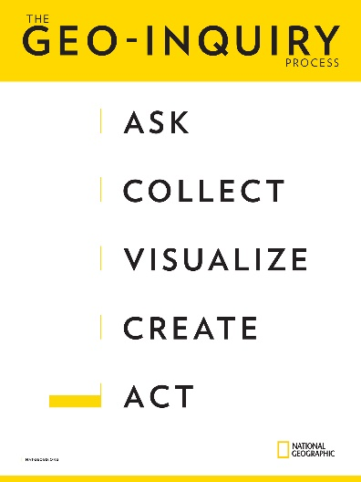
Step 4: In this phase of the project, students will put the information they gathered and the data they analyzed into context using it to tell a Geo-Inquiry Story that answers their Geo-Inquiry Question.

Step 5: The final step in students’ projects is to share their Geo-Inquiry Story and to use their stories to take action. Students explore the best way to present their work, identifying their audience, and, finally, sharing their story and reflecting on the process

2018 GeoInquiry Institute – APPLICATION FORM (2 pages)
Please type or print clearly. Direct questions to Gale.Ekiss@asu.edu

Participant 1
Name _________________________________________________________________________
Last First Middle

Home Mailing Address____________________________________________________________
City _________________________________ Zip _______________

Home Phone _________________________ Cell______________________________________
(area code) (area code)
email__________________________________________________________(used all year long)

How many miles from Rhodes Jr. High? _________
Number of students you are currently teaching ____________
I am a middle school _______ social studies educator ________ science educator

______other Explain______________________________________________________________

Participant 2
Name __________________________________________________________________________
Last First Middle

Home Mailing Address____________________________________________________________
City _________________________________ Zip _______________

Home Phone _________________________ Cell______________________________________
(area code) (area code)
email__________________________________________________________(used all year long)

How many miles from Rhodes Jr. High?_________
Number of students you are currently teaching ____________
I am a middle school _______ social studies educator ________ science educator

______other Explain____________________________________________________________

School Mailing Address__________________________________________________________
City _________________________________________________________Zip _____________
School District __________________________________________________________________
Is your school a Title One school? ________
What is the ethnic mix of your school?
___% Asian American ___% African American
___% Latino/a American ___% Native American
Special skills that you bring to the Institute
_______________________________________________________________________________
_______________________________________________________________________________

ATTACHMENTS -- Please include the following with this application:
1) Written Response (Please answer these three questions in 450 words or less)
- Why are you interested in this professional development opportunity?
- If selected, how do you envision incorporating what you learn into your curriculum?
- How do you anticipate this summer institute will impact your teaching practices?
2) Two letters of reference (these can be mailed or emailed separately):
- From your principal--arrange a letter of reference that addresses your skills in the classroom, plus your district’s willingness to facilitate your presentation of at least one staff development workshop in your district.
- From a colleague--seek a letter that discusses your classroom effectiveness and rapport with fellow educators. We are looking for people who play well with others.
- A check for $50 made out to the Arizona Geographic Alliance. This money will be refunded in its entirety if you
  - are not accepted.
  - cancel in writing by May 20, 2018.
  - complete the institute sessions.
DEADLINE to apply: March 20, 2018

Send completed application and attachments to:
Arizona Geographic Alliance
ASU School of Geographical Sciences & Urban Planning
P O Box 875302
Tempe, AZ 85287-5302
Or FAX to: 480-965-8313 c/o Gale Ekiss Or email to Gale Ekiss at Gale.Ekiss@asu.edu

I agree to the following:
- Attend all Institute days (June 22 and June 23) and complete all homework assignments.
- Complete Phase 1 of Nat Geo Ed Certificate online.
- Complete a GeoInquiry project overview by July 1, 2018.
- On Sept 15, 2018, show evidence of project implementation and on target to complete by November 30th deadline.
- Train other teachers in my school district based on what I have learned in this institute.
- Be active in the Arizona Geographic Alliance.
- I understand the stipend will be paid when all requirements are met (deadline 11/30/2018).

_____________________________________________ Signature

