1.Title / Content Area: | Moundbuilder and Pueblo Cultures | 
2. Developed by: | Anne Marshall
3. Grade Level: | 6
4. Geographic Thinking Skill(s): | The geographically informed person knows...  -How to use maps and other geographic representations and spatial thinking to understand and communicate information.  -How the physical and human characteristics of places affect lifestyle.  -The processes, patterns, and functions of human settlement.  -How to apply geography to interpret the past.
5. Essential Question: | How does geography dictate differences in culture?
6. Contextual Paragraph (Connect to Geographic Thinking) | The Mississippian Culture and the cultures preceding it (Adena and Hopewell) developed at the same rate as the Southwestern prehistoric peoples: Anasazi, Mogollon, and Hohokam, but because of their locales their lives were much different.

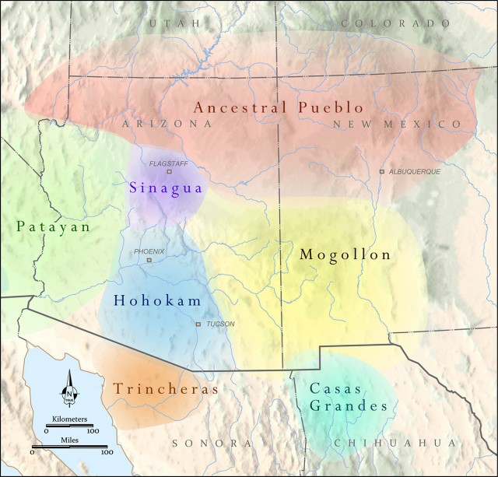
Annotated Resource Set (ARS)

Drawings Pueblo Layout-Cannonball Pueblo | Kiva Photos | Mound Photo | (Resource Title Here) | Mound Photo | Southwest Climate and Culture
for use with diagram analysis tool (modified map tool) | for use with image analysis tool | for use with image analysis tool | (Context) | for use with image analysis tool | for use with image analysis tool
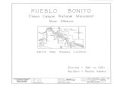 | 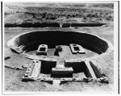 | 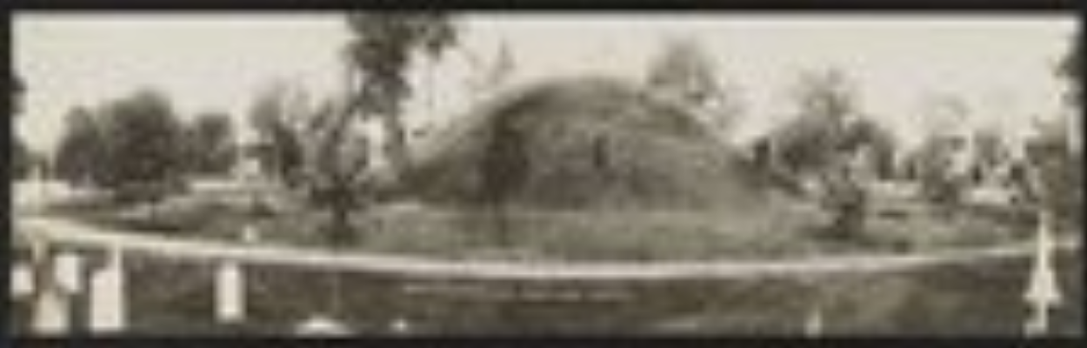 |  | 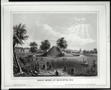 | 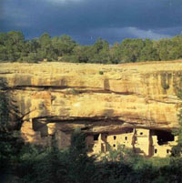
http://www.loc.gov/resource/hhh.co0918.sheet?st=gallery | http://www.loc.gov/resource/hhh.nm0171.photos?st=gallery | http://hdl.loc.gov/loc.pnp/ds.02610 |  | http://hdl.loc.gov/loc.pnp/cph.3b21405 | http://www.ncdc.noaa.gov/paleo/ctl/cliihis1000.html

Notes/Comments:

Drawings Mound Layout | Drawing of cross section of mound | Photo Pueblo Structure | Second Mesa Structure | Cahokia Mound Photo | Map of Southwest Prehistoric Peoples
for use with diagram analysis tool (modified map tool) | for use with final project | scroll down for photo of ruins  for use with image analysis tool | for use with image analysis tool | for use with image analysis tool | for use with map analysis tool  scroll down for ma
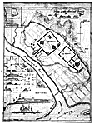 | 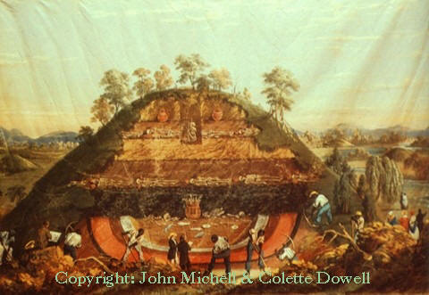 | 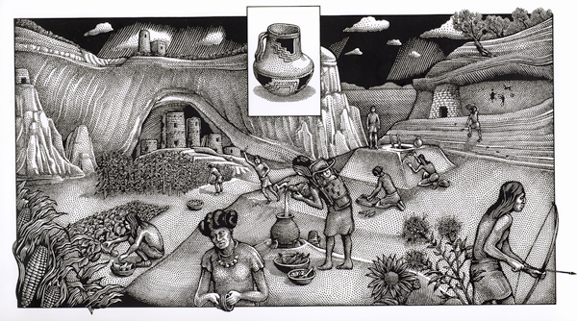 | 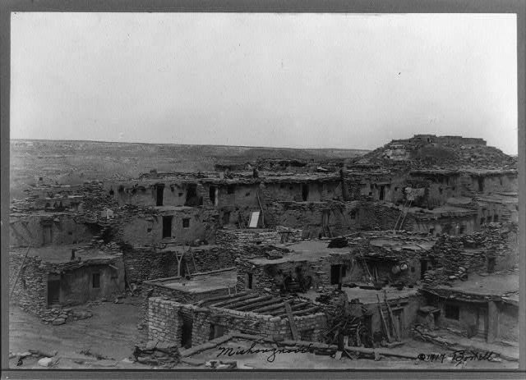 | 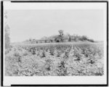 | 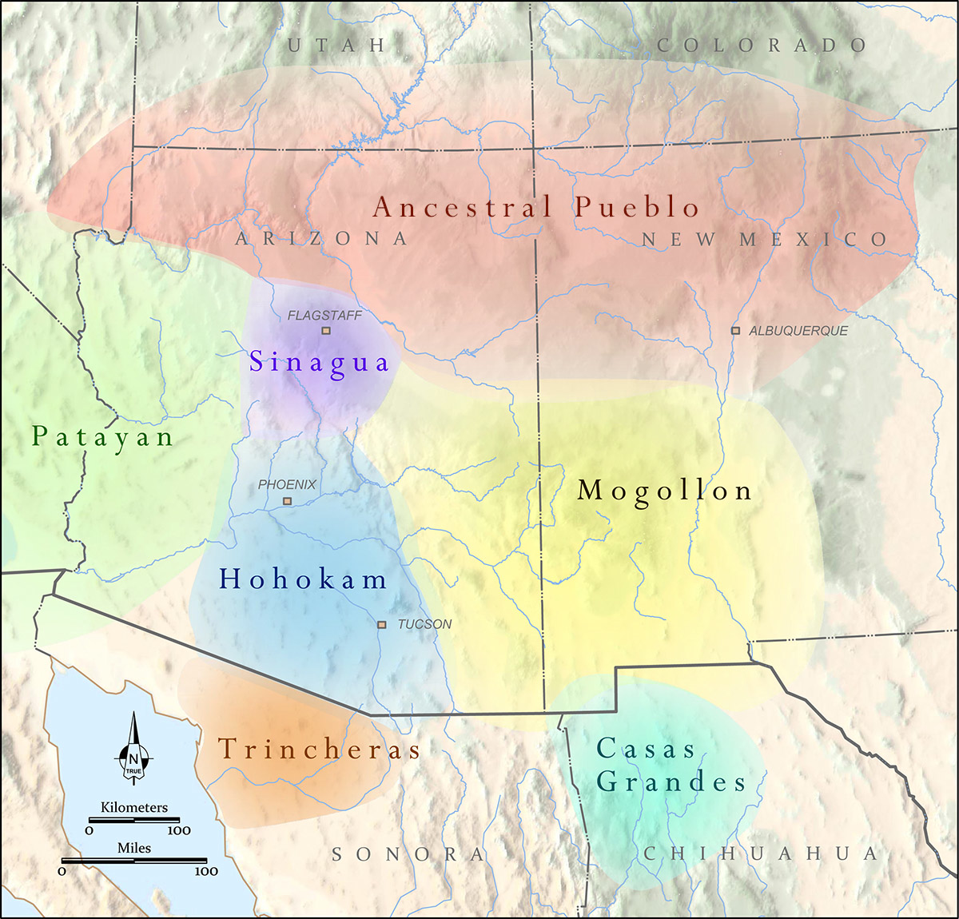
http://lcweb2.loc.gov/cgi-bin/query/r?ammem/mcc:@field(DOCID+@lit(mcc/048)) | http://www.robertschoch.net/Amazing Amerindian Antiquities of Old Florida.htm | http://ilovehistory.utah.gov/people/first_peoples/ancestral_puebloan.html | http://www.loc.gov/pictures/resource/cph.3b34295/ | http://www.loc.gov/pictures/item/97505973/ | http://www.archaeologysouthwest.org/2013/11/25/back-to-basics-part-1/

Notes/Comments:

Mississippian map | Southeast Pre-history Climate | US Pre-history Climate and Culture
for use with map analysis tool  copy url and paste into browser | Historical document re: weather in SE US | SW US Weather
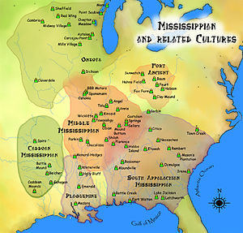 | 
https://en.wikipedia.org/wiki/Mississippian_culture | http://deepblue.lib.umich.edu/bitstream/handle/2027.42/75299/j.1749-6632.1961.tb50071.x.pdf?sequence=1&isAllowed=y | http://www.digitalhistory.uh.edu/disp_textbook.cfm?smtID=2&psid=3564

Notes/Comments:

Phase II
Foundations Annotations
7. Curriculum Connections

This unit will continue the class’s study of Ancient Civilizations per Arizona State Standards. Although not formally they will be comparing and contrasting to other civilizations they have learned about.
8. Curriculum Standards

Strand 1: American History:
Concept 2: Early Civilizations:
PO 3. Describe the cultures of the Mogollon, Ancestral Puebloans (Anasazi), and Hohokam:
- location, agriculture, housing, arts, and trade networks
- b. how these cultures adapted to and altered their environment
PO 4. Describe the Adena, Hopewell, and Mississippian mound-building cultures:
- location, agriculture, housing, arts, and trade networks
- how these cultures adapted to and altered their environment

Strand 5: Geography
Concept 2: Places and Regions
PO 3. Analyze the causes and effects of settlement patterns.
PO 4. Identify how factors such as river/coastal civilizations and trade influenced the location, distribution, and interrelationships of economic activities over time and in different regions.

Concept 4: Human Systems
PO 1. Interpret the demographic structure of places and regions using a population pyramid.
PO 2. Describe the environmental, economic, cultural, and political effects of human migrations and cultural diffusion on places and regions.
PO 3. Analyze the causes and effects of settlement patterns.
PO 4. Identify how factors such as river/coastal civilizations and trade influenced the location, distribution, and interrelationships of economic activities over time and in different regions.
PO 5. Identify cultural norms that influence different social, political, and economic activities of men and women.

9. Content & Thinking Objectives

TSWD analysis by interpreting civilizations based on climate and locale.
TSWD analysis by comparing and contrasting individual examples of the layouts of communities of diverse cultures.

TSW will use diagram analysis to look at diagrams of a pueblo and of a mound.
TSW will use image analysis tool to look at several examples of pueblos and of mounds.
TSW will use close reading strategies to examine climate in locales of pueblos and of mounds.
TSW compare/contrast diagrams of mound and pueblo to determine similarities and differences using LOC tool with geographical emphasis.

11. Assessment Strategies

TSW create a cross-section of a mound and a pueblo highlighting differences in building materials and things such as protection from weather, animals, etc. Will be graded using a poster/model rubric.

